Child and Youth Lead officer

28 Hours a week (Monday-Thursday)
Salary: £26,197 pro rata

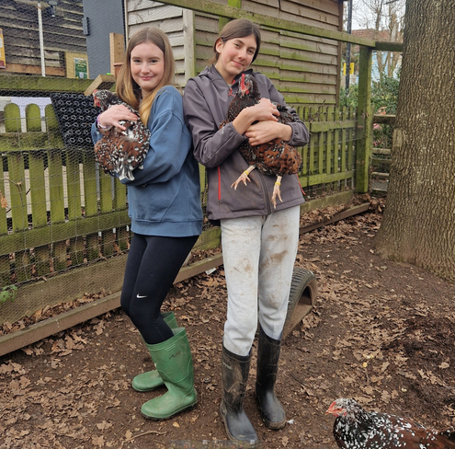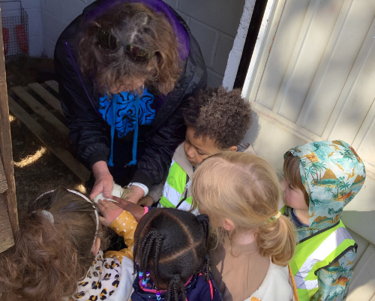

Who we are
St Werburghs City Farm is a vibrant community hub in the heart of Bristol. We manage over 18 acres of green space, including a small farm, community garden, conservation area and plant social enterprise. Our mission is to enhance the skills, health, and connections of people of all ages, including those experiencing a range of disadvantages, through volunteering and educational opportunities.
We offer diverse programmes that provide hands-on experience in areas like gardening, animal care, cooking, and landscaping. Our work strengthens the bond between land, animals, and people, while recognizing the importance of green spaces for health and wellbeing. Committed to inclusion, we focus on addressing inequalities in access to green space, local food, and agricultural opportunities, particularly for those from disadvantaged or marginalised backgrounds.
We are working to create a future where communities grow, green spaces flourish, and together we thrive.

What you will love about working here
- Being part of a welcoming team that strives for greater inclusion and equity
- Knowing that your job has a positive impact for an entire community
- 25 days annual leave entitlement and bank holiday pro rata
- Access to the cycle-to-work scheme
- Dog-friendly office (conditions apply)
- Access to training opportunities and reflective practice

About the role and responsibilities
We are looking for someone who wants to be part of a team that makes a positive and lasting difference to young people’s lives.

- You will support the project manager to plan, resource and deliver our child and youth programme.
- You will lead our W2L programme on Mondays and Tuesdays during term time – supporting young people to learn about animal care and other activities.
- You will support other 1-1 and group sessions for young people with support needs.
- You will run short courses (forest school sessions/one off visits for schools/community groups at our Boiling Wells nature reserve site.
- You will support our youth club on Tuesday evenings.
- You will help plan and deliver holiday activities - including taking the lead on organising and delivering our summer day camp.
- You will help monitor and evaluate young people’s progress.

Your skill set and experience

Essential
- Experience working with young people in an outdoor setting.
- Experience in managing the different personalities of young people, including those with complex needs.
- A desire to learn about working with animals.
- Good communicator with the ability to work consistently, collaboratively and respectfully with a diverse team and develop good relationships.
- Ability to support and inspire children and young people.
- An understanding of how to plan session effectively.
- Ability to give clear feedback on sessions.
- Ability to work within organisational policies and procedures.
- Knowledge of safeguarding practices when working with young people.
Desirable
- Experience of working with animals.
- Forest School Level 3 certificate.

Your approach
- Collaborative, positive, confident and honest.
- Reflective of your work and a willingness to learn new skills.
- Able to work without being supervised.
- Calm and boundaried when confronted with challenging behaviour.
- Commitment to equity, diversity, inclusion, and accessibility.

General
We expect all staff to maintain a flexible working ethos, promote the city farm's values, aims and objectives and present a positive image to beneficiaries and the public. All staff are expected to abide by the organisation’s policies and to carry out any other duties commensurate with the responsibilities of their post. The successful candidate will be required to undertake an enhanced DBS check.

Job Title: | Child and Youth Lead officer
Responsible to: | Child and Youth Project Manager
Place of work: | St Werburghs City Farm
Hours of work: | 28 hrs per week Monday-Thursday
Contract Type: | Permanent
Annual leave: | 25 days plus statutory holidays pro rata
Probationary period: | 3 months
Starting Salary: | £26,197 pro rata
Pensions: | St Werburghs City Farm offer pensions in line with the NEST scheme

If you have any questions about this opportunity, please contact childandyouth@swcityfarm.co.uk

